

Ασφάλεια στο Φυσικό Επίπεδο σε Ασύρματα Κανάλια με Διαλείψεις

Αρίστος Καράμπελας-Τιμοτίεβιτς

ΣΧΟΛΗ ΘΕΤΙΚΩΝ ΕΠΙΣΤΗΜΩΝ

ΤΜΗΜΑ ΠΛΗΡΟΦΟΡΙΚΗΣ ΚΑΙ ΤΗΛΕΠΙΚΟΙΝΩΝΙΩΝ

ΠΤΥΧΙΑΚΗ ΕΡΓΑΣΙΑ

ΥΠΕΥΘΥΝΟΣ

Θεόδωρος Τσιφτσής

Καθηγητής

Λαμία, Ιανουάριος 2023

ΣΧΟΛΗ ΘΕΤΙΚΩΝ ΕΠΙΣΤΗΜΩΝ

ΤΜΗΜΑ ΠΛΗΡΟΦΟΡΙΚΗΣ ΚΑΙ ΤΗΛΕΠΙΚΟΙΝΩΝΙΩΝ

Ασφάλεια στο Φυσικό Επίπεδο σε Ασύρματα Κανάλια με Διαλείψεις

Αρίστος Καράμπελας-Τιμοτίεβιτς

ΠΤΥΧΙΑΚΗ ΕΡΓΑΣΙΑ

ΥΠΕΥΘΥΝΟΣ

Θεόδωρος Τσιφτσής

Καθηγητής

Λαμία, Ιανουάριος 2023



SCHOOL OF SCIENCE

DEPARTMENT OF COMPUTER SCIENCE & TELECOMMUNICATIONS

Physical Layer Security Over Fading Channels

Aristos Karampelas-Timotievits

FINAL THESIS

ADVISOR

Theodoros Tsiftsis

Professor

Lamia, January 2023

|  |
| --- |
| *«Με ατομική μου ευθύνη και γνωρίζοντας τις κυρώσεις (1), που προβλέπονται από της διατάξεις της παρ. 6 του άρθρου 22 του Ν. 1599/1986, δηλώνω ότι:* |
| *1.    Δεν παραθέτω κομμάτια βιβλίων ή άρθρων ή εργασιών άλλων αυτολεξεί χωρίς να τα περικλείω σε εισαγωγικά και χωρίς να αναφέρω το συγγραφέα, τη χρονολογία, τη σελίδα. Η αυτολεξεί παράθεση χωρίς εισαγωγικά χωρίς αναφορά στην πηγή, είναι λογοκλοπή. Πέραν της αυτολεξεί παράθεσης, λογοκλοπή θεωρείται και η παράφραση εδαφίων από έργα άλλων, συμπεριλαμβανομένων και έργων συμφοιτητών μου, καθώς και η παράθεση στοιχείων που άλλοι συνέλεξαν ή επεξεργάσθηκαν, χωρίς αναφορά στην πηγή. Αναφέρω πάντοτε με πληρότητα την πηγή κάτω από τον πίνακα ή σχέδιο, όπως στα παραθέματα.*  *2.    Δέχομαι ότι η αυτολεξεί παράθεση χωρίς εισαγωγικά, ακόμα κι αν συνοδεύεται από αναφορά στην πηγή σε κάποιο άλλο σημείο του κειμένου ή στο τέλος του, είναι αντιγραφή. Η αναφορά στην πηγή στο τέλος π.χ. μιας παραγράφου ή μιας σελίδας, δεν δικαιολογεί συρραφή εδαφίων έργου άλλου συγγραφέα, έστω και παραφρασμένων, και παρουσίασή τους ως δική μου εργασία.*  *3.    Δέχομαι ότι υπάρχει επίσης περιορισμός στο μέγεθος και στη συχνότητα των παραθεμάτων που μπορώ να εντάξω στην εργασία μου εντός εισαγωγικών. Κάθε μεγάλο παράθεμα (π.χ. σε πίνακα ή πλαίσιο, κλπ), προϋποθέτει ειδικές ρυθμίσεις, και όταν δημοσιεύεται προϋποθέτει την άδεια του συγγραφέα ή του εκδότη. Το ίδιο και οι πίνακες και τα σχέδια*  *4. Δέχομαι όλες τις συνέπειες σε περίπτωση λογοκλοπής ή αντιγραφής.* |

Ημερομηνία: ……/..…/20……

Ο – Η Δηλ.

*(1)*   *«Όποιος εν γνώσει του δηλώνει ψευδή γεγονότα ή αρνείται ή αποκρύπτει τα αληθινά με έγγραφη υπεύθυνη δήλωση*

*του άρθρου 8 παρ. 4 Ν. 1599/1986 τιμωρείται με φυλάκιση τουλάχιστον τριών μηνών. Εάν ο υπαίτιος αυτών των πράξεων*

*σκόπευε να προσπορίσει στον εαυτόν του ή σε άλλον περιουσιακό όφελος βλάπτοντας τρίτον ή σκόπευε να βλάψει άλλον, τιμωρείται με κάθειρξη μέχρι 10 ετών.»*

# Περίληψη

Στην σύγχρονη εποχή οι ασύρματες επικοινωνίες γίνονται όλο και πιο διαδεδομένες. Τεχνολογίες όπως η ασύρματη μετάδοση πληροφορίας, η ασύρματη διάδοση ενέργειας και οι τηλεπικοινωνίες εξελίσσονται συνεχώς. Τα συστήματα ασύρματης μετάδοσης σημάτων μπορούν εύκολα να βρεθούν υπό τον κίνδυνο της μη εξουσιοδοτημένης πρόσβασης τρίτου. Επομένως η αξιολόγηση των καναλιών μετάδοσης της πληροφορίας για την ποιότητα της ασφάλειας που εμφανίζουν αλλά και η μελέτη τους υπό διάφορες συνθήκες είναι μείζονος σημασίας. Η παρούσα πτυχιακή εργασία αποσκοπεί στην μελέτη, αξιολόγηση και προσομοίωση της βασικής μετρικής ασφαλείας των ασύρματων καναλιών, ήτοι η πιθανότητα διακοπής ασφάλειας. Αρχικά γίνεται μια εισαγωγή στις διάφορες έννοιες που θα παρουσιαστούν. Εν συνεχεία παρουσιάζονται αναλυτικά και μέσω προσομοιώσεων τα μοντέλα συστημάτων για πέντε ασύρματα κανάλια με την παρουσία διαλείψεων, Rayleigh, Weibull, Rice, Nakagami-μ και Generalized Gamma. Τέλος, εκφράζονται συμπεράσματα για την αξιολόγηση της ασφάλειας του κάθε καναλιού, καθώς και μελλοντικές επεκτάσεις.

# Abstract

In modern times, wireless communications are becoming more and more widespread. Technologies such as wireless information transmission, wireless power propagation and telecommunications are constantly evolving. Wireless signal transmission systems can easily come under the risk of unauthorized access by third parties. Therefore, evaluating information transmission channels for their security quality and studying them under various conditions is of major importance. This thesis aims to study, evaluate, and simulate the key security metric of wireless channels, namely the secrecy outage probability. First, an introduction to the various concepts to be presented is given. Then the system models for five wireless channels in the presence of flat fading, Rayleigh, Weibull, Rice, Nakagami-M and Generalized Gamma, are presented in detail and through simulations. Finally, conclusions are expressed for the security evaluation of each channel, as well as for future extensions.

**Contents**

Περίληψη 9

Abstract 10

Section 1. Introduction 1

1.1. Wireless Communications 1

1.2. Flat-Fading Channels 1

1.3. Performance evaluation and metrics 2

1.4. Secrecy as a performance metric 3

1.4.1. Definition 3

1.4.2. Secrecy outage probability 3

Section 2. Literature Review 5

Section 3. Rayleigh Fading Channel 6

3.1. System model of Rayleigh fading channel 6

3.2. Secrecy outage probability analysis 10

3.3. Simulations 13

3.3.1. Simulation of the analytical expression 14

3.3.2. Simulation of a realistic system model 18

Section 4. Weibull Fading Channel 22

4.1. System model of Weibull fading channel 22

4.2. Secrecy outage probability analysis 23

4.3. Simulations 25

4.3.1. Analytical expression simulations 25

4.3.2. Realistic system model simulations 25

Section 5. Rician Fading Channel 26

Section 6. Nakagami-μ Fading Channel 27

Section 7. Generalized Gamma Fading Channels 28

Section 8. Conclusion 29

Bibliography 30

# Section 1. Introduction

## 1.1. Wireless Communications

Wireless communication refers to the transfer of information or power between two or more points that are not connected by a physical link. The most common wireless technologies are radio, infrared and microwave. The whole basis of communication relies on the use of electromagnetic waves to transmit information from one point to another. These waves can be either guided, such as those transmitted over a wire or cable, or unguided, such as those transmitted through the air.

There are several factors that can affect the performance of a wireless communication system, the distance between the transmitter and receiver (Friis’ equation), the presence of obstacles or interference (Rayleigh), and the frequency of the electromagnetic waves being used.

## 1.2. Flat-Fading Channels

A flat fading channel is a type of wireless communication channel that experiences constant, or flat, fading over the duration of a transmitted signal. Flat fading occurs when the signal strength of the transmitted signal remains constant, or nearly constant, over time. Flat-fading channels are typically found in wireless systems that operate over short distances, such as those used in indoor environments or in personal area networks (PANs). These channels are characterized by low levels of fading, or signal variation, over time.

There are several factors that can cause flat fading in a wireless communication channel, including reflections from nearby objects, scattering from small obstacles, and the movement of the transmitter or receiver. One way to mitigate effects of flat fading is to use multiple antennas on both the transmitter and the receiver. This can help to improve the signal-to-noise ratio (SNR) and increase the reliability of the communication link. Other techniques, such as error correction coding and frequency-hopping, can also be used to improve the performance of a wireless system in a flat-fading channel.

## 1.3. Performance evaluation and metrics

Thus, it is important to evaluate the performance of a wireless channel since wireless communications are prone to various types of interference and noise that can degrade the quality of the signal. By evaluating the performance of a wireless channel, it is possible to identify any problems or limitations in the system and take steps to improve communication performance. The performance can be evaluated using a variety of metrics, including:

1. Signal strength: This metric refers to the power of the signal at the receiving end. Stronger signal results in better communication performance.
2. Data rate: This measures the speed at which data is transmitted over the wireless channel.
3. Bandwidth: This measures the amount of data that can be transmitted over the wireless channel in each period of time.
4. Error rate: This measures the percentage of transmitted data that is received incorrectly at the receiving end.
5. Interference: This measures the amount of noise or other signals that can disrupt communication over the wireless link.

Additionally, there are some metrics that are considered crucial about the evaluation of a digital wireless communication system. Those are, the signal-to-noise ratio (SNR), the outage probability and the average bit-error rate. SNR is probably the most common and well understood performance measure metric of a digital communication system, and overall communication systems. Most often it is measured at the output of the receiver and is strongly related to the data detection process. It is characterized as the easiest metric to evaluate and is a valid indicator about the overall quality of the system. In the concern of communications under fading channels, the more appropriate metric is the average SNR, where the term average denotes the statistical average of the random variable, subject to the fading distribution model. The random variable in these systems is the instantaneous SNR, which acts as the random variable of the distribution.

Evaluating the performance of a wireless channel can also be important for optimizing the use of the wireless spectrum. By understanding how different types of interference and noise affect the performance of a wireless system, it is possible to design and deploy the system in a way that maximizes its efficiency and minimizes its impact on other users of the spectrum.

## 1.4. Secrecy as a performance metric

### 1.4.1. Definition

Secrecy, or the ability to keep the content of a communication private, can also be considered a performance metric in wireless channels, particularly in situations where the security of the communication is important. In wireless systems, secrecy can be achieved through various methods, such as encryption, which transforms the data into a form that can only be understood by someone with the proper decryption key. Other methods for achieving secrecy in wireless systems include using secure protocols for communication, authenticating the identity of the sender and receiver, and using techniques to detect and prevent unauthorized access to the communication.

Evaluating the performance of a wireless channel in terms of secrecy can involve measuring the effectiveness of the methods used to protect the communication from being intercepted or compromised. For example, the strength of the encryption algorithm and the robustness of the authentication protocols can be evaluated to determine the level of secrecy that can be achieved. Overall, secrecy is an important performance metric in wireless channels, particularly in situations where the security of communication is critical, such as in military, financial, or healthcare applications.

### 1.4.2. Secrecy outage probability

The secrecy outage probability (SOP) is the probability that the mutual information between the transmitter and the intended receiver is less than the mutual information between the transmitter and an eavesdropper, given a certain level of transmit power and channel conditions. In other words, it is the probability that the transmitted message cannot be kept secret from an eavesdropper due to poor channel conditions or insufficient transmit power. Evaluating SOP is an important task metric in the field of secure communication, as it determines the probability that the transmitted message will be successfully intercepted by an eavesdropper. To ensure the security of a communication system, it is important to minimize the secrecy outage probability as much as possible.

The evaluation of a system based on its secrecy demonstrates a variety of applications, including military communications, financial transactions, and private messaging. It is also used to design and optimize secure communication systems, by determining the necessary transmit power and channel conditions required to achieve the desired level of security.

# Section 2. Literature Review

# Section 3. Rayleigh Fading Channel

The Rayleigh fading or Rayleigh channel is a statistical model for the effect of a propagation environment on a radio signal, such as that used by wireless devices. Rayleigh fading models assume that the magnitude of a signal that has passed through such a transmission medium will vary randomly, or fade, according to a Rayleigh distribution. This distribution is the radial component of the sum of two uncorrelated Gaussian random variables. Rayleigh fading is viewed as a reasonable model for tropospheric and ionospheric signal propagation as well as the effect of heavily built-up urban environments on radio signals. Rayleigh fading is most applicable when there is no dominant propagation along a line of sight between the transmitter and receiver. If there is a dominant line of sight, Rician fading may be more applicable.

## 3.1. System model of Rayleigh fading channel

As foretold, the scatters model is a reasonable one when there are many objects in the environment that scatter the radio signal before it arrives at the receiver. The central limit theorem holds that, if there is sufficiently much scatter, the channel impulse response will be well-modelled as a Gaussian process irrespective of the distribution of the individual components. This means the impulse response varies based on time and the symbol delay. If there is no dominant component to the scatter, then such a process will have zero mean and phase evenly distributed between 0 and 2π radians. The envelope of the channel response will therefore be Rayleigh distributed.

Calling this random variable , it will have a pdf:

Where which is the second moment of the random variable, in other words it is called mean-squared value, which is the mean of its square and not the square of its mean. When the distribution is centered on zero, then the second moment is the variance of the random variable since:

As told, the distribution is zero-centered, which means that , thus . This means that:

Rayleigh fading is exhibited by the assumption that the real and imaginary parts of the response are modelled by independent and identically distributed zero-mean Gaussian processes so that the amplitude of the response is the sum of two such processes.

Based on the GG distribution of the random variable R is given by:

In this equation the a is the fading parameter, c is the normalized variance of the channel envelope R, and is the ath mean square of the channel envelope. The gamma function is the following:

By changing the parameters of the GG distribution, we can obtain other famous distributions like Rayleigh, Rice, Weibull and Nakagami-μ. Beginning the substitution using the Rayleigh parameters, where and .

Before returning to this equation, we should calculate the gamma function:

Since , then:

The upper equation is the exact same as the Rayleigh model that we presented in relation (1). The , thus the final model equation is:

The problem must be approached from a channel perspective. The main metric for a channel is the capacity and the SNR, in other words the quality of the transmitted signal. Thus we are going to assume that in our earlier formulas, the main random variable corresponded to the SNR of the channel and not the actual scale. Doing that we are talking about the distribution of the SNR which varies with time. The general pdf of the SNR for a GG fading channel is given as:

In the upper formula, the parameter k is assigned as the Destination (D) or the Eavesdropper (E) channel. are the normalized variances of the two channel envelopes based on the bandwidth. The average SNR is defined as:

The ratio is the energy per bit to the noise power spectral density. By substituting the parameters for the Rayleigh fading (, and assuming that the parameters are the same for both the main and eavesdropper channels, we have the following equation:

As for the cumulative density function, we have the following equation, which is based on the lower gamma function.

We know that the lower gamma function has the following expression:

Thus, the previous equation becomes.

The former can be solved very easily using integration by parts, resulting in the following final expression:

The upper formulas are valid when it is known that the channel is overcome by Rayleigh fading.

## 3.2. Secrecy outage probability analysis

Secrecy Outage Probability is defined as the probability that the instantaneous secrecy capacity falls below a predesignated target bitrate. Simplifying the definition, this is the probability that the channel will seize being secure, and that the eavesdropper can discern critical information about the transmitted data. Thus, SOP is an important performance measurement, which is widely used to characterize a wireless communication system.

SOP can be defined as:

By considering that we are using bit transmission we have the capacity as it was defined by the Shannon-Hartley theorem. In the upper formula the describes the predesignated threshold capacity for the secrecy outage. Respectively, the describes the ratio of the destination capacity to eavesdropper capacity.

This capacity is normalized by the channel bandwidth. Thus, we have the following:

We will apply some simplifications on the previous expression by using the function which is 1-to-1, keeping the monotony of the function unchanged.

To calculate the probability, we need to calculate the area below the pdf up until the break point. This is achievable by using the cumulative distribution function:

We set , and then apply the first integral:

And then we also integrate for the second SNR, which is the eavesdropper’s channel.

We solve the inner integral by using the formula of the CDF, and we have the following:

Both the cumulative and the density functions are known from earlier calculations. We can also notice that the cumulative is irrespective of which allows us to place it on the outside of the integral. Then we will attempt to solve it:

Respectively, we have the following:

The final integral to be solved is the following:

We will now attempt to simplify the equation:

Our solution of the upper integral assumes that the big terms in the exponential powers will be simplified by substituting them with some placeholder variables.

Using this separation, we will execute the multiplication inside the integral

Thus, the integral will be transfigured as such:

We will solve each integral separately:

Substituting the solutions in the initial integral we have

Since we know that , then we can simulate the expression using various values of the threshold channel capacity and see how the SOP changes, responding to the capacity.

## 3.3. Simulations

To simulate the secrecy outage probability of the Rayleigh fading channel we divided the procedure into two discrete experiments. The first demonstrates the theoretical calculations based on user given values for the various communication parameters. The second seeks to validate the theoretical results by implementing a simple communication system and evaluating the SOP, through realistic experimental values.

### 3.3.1. Simulation of the analytical expression

The analytical experiment of the SOP is going to be based on the closed form expression we calculated in the previous section.

The during the simulation of the analytical closed form, it is assumed that the threshold secrecy capacity is , the noise SNR is and that the ratio of the legitimate receiver (destination) to the eavesdropper is a vector K. The vector K receives has values in the range -10 to 20, and it is measured in dB. The simulation can be divided into three distinct simulations. The first simulation investigates the relationship between the eavesdropper average SNR and the SOP. During the second simulation, the corresponding relation with the destination average SNR is visited. Finally, the final relation is between the ratio K and the SOP.

The first two simulations are very straightforward. The simulations are created by defining a vector of values for the eavesdropper average SNR and for the destination average SNR. During each simulation, the complementary factor, it being the eavesdropper during the destination simulation and vice-versa, is a constant value. For simulation values for the average eavesdropper SNR varying from 0 to 10 and step 0.1, the experiment yielded the following graph for the Secrecy Outage Probability.

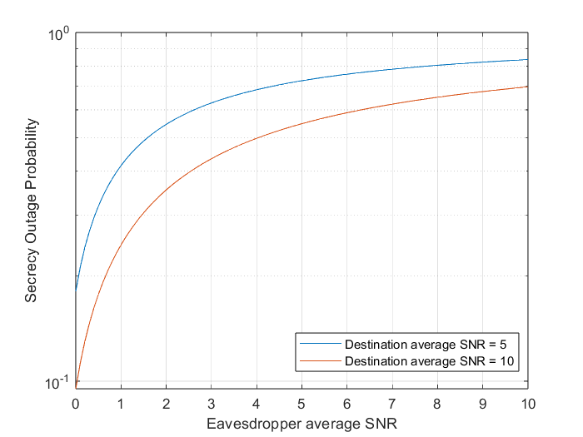

Figure 1: Logarithmic scale plot of the SOP during varying eavesdropper SNR

As it is obvious, the SOP demonstrates an ascending figure, which translates to the probability of secrecy outage increasing as the eavesdropper SNR is increased. The corresponding simulation for varying destination average SNR is plotted in Fig.2.

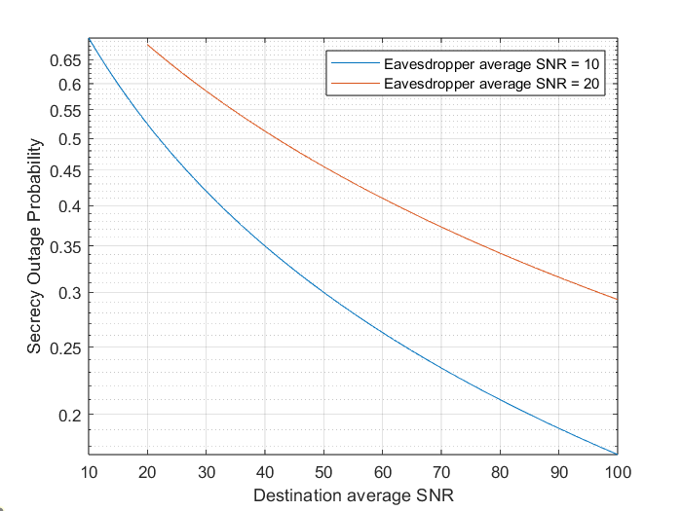

Figure 2: Logarithmic scale plot of the SOP during varying destination SNR

It is plainly witnessed that the SOP is decreasing in response to the increase of the average destination SNR. In simpler words, the destination’s SNR is becoming much greater than the eavesdropper suggests that the channel is secure enough for transmission.

The final simulation, which exploits the relationship between the destination and the eavesdropper, the SNR ratio of the two receivers requires some additional steps. The first step in this simulation is to convert the decibels of the K ratio into numbers using the standard dB conversion.

Continuing, random values for the eavesdropper average SNR are chosen. Another assumption is that the legitimate receiver’s average SNR (destination SNR) is K-times greater than the eavesdropper’s average SNR:

Finally, from the analytical solution we have that . The MATLAB script which implements the simulation can be found in Appendix 1 (*add link*). The generated figure is shown in Fig.3.

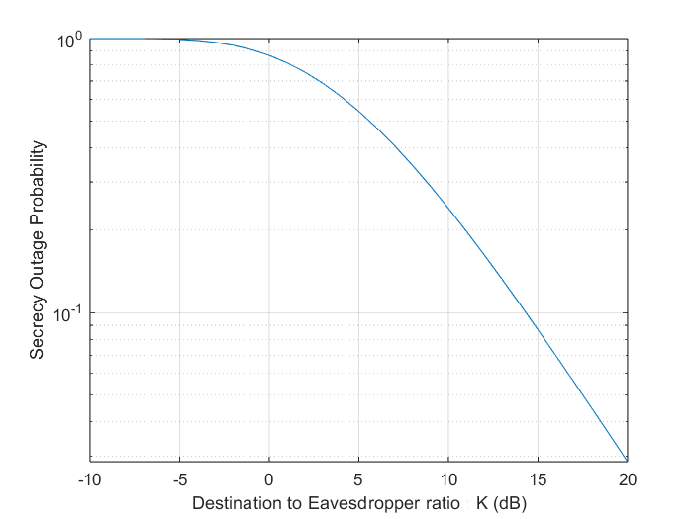

Figure 3: Simulation plot of the analytical SOP expression

We can see that as the ratio increases, the SOP decreases. This is because the eavesdropper receives a much smaller SNR than the legitimate user, making the signal detection much harder for the eavesdropper. We can see that the probability of security outage is most unlikely the larger the ratio of the SNR becomes.

Finally, the influence of threshold capacity is shown in Fig.4, where the simulation is run for the same parameters as the K-ratio simulation, but with also, varying threshold capacity in the range from 2 to 5.

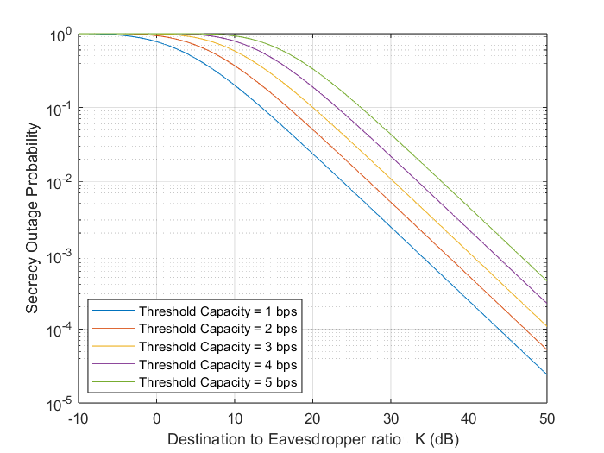

Figure 4: Simulation plot of the analytical SOP expression in respect to varying K ratio and threshold capacity

It is clearly shown that an increasing threshold capacity increases the insecure ratio, which is logical as the greater the threshold, the longer the security outage duration.

### 3.3.2. Simulation of a realistic system model

The system model we are going to use in our simulation is (Fig. 5):

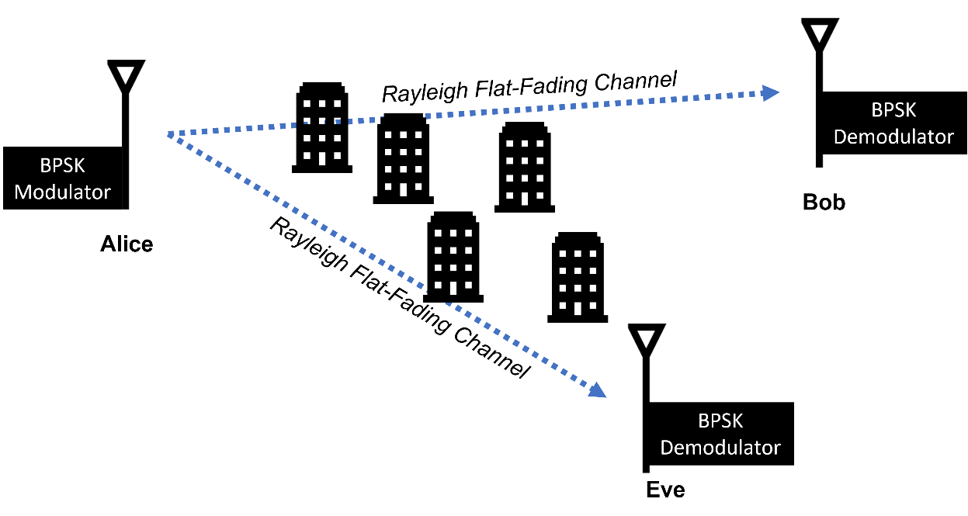

Figure 5: The system model for the Rayleigh channel simulation

To calculate the secrecy outage probability in a system with BPSK modulation scheme and a Rayleigh flat fading channel, where there are two receivers (a legitimate and an eavesdropper) and the secrecy outage probability is calculated in respect to the ratio of their signal-to-noise ratios (SNRs), the required steps are as follows:

1. Definition of the system parameters, such as the number of bits, the modulation type, and the noise SNR.
2. Generation of a sample of 1000 random bits using the randi function.
3. Modulation of the bits using BPSK modulation by mapping each bit to a complex-valued symbol.
4. Generation of a sample of channel gains from the Rayleigh distribution using the randraw function for both the destination and the eavesdropper.
5. Calculation of the received signal at the destination and the eavesdropper by multiplying the transmitted signal by the channel gains.
6. AWGN addition to the received signal using the AWGN function, with the noise SNR specified in dB.
7. Demodulation of the received signal at the destination and the eavesdropper using BPSK demodulation.
8. Calculation of the SNR of the received signal at the destination and the eavesdropper using the following formula:

where is the power of the signal and is the power of the noise.

1. Calculation of the secrecy outage probability as the fraction of transmitted bits where the ratio of the SNRs of the destination and the eavesdropper is less than a certain threshold.

The signal-to-noise ratio (SNR) of a symbol is typically calculated after demodulation in the receiver. This is because the SNR is a measure of the strength of the signal relative to the background noise, and it is usually calculated in the baseband domain after the signal has been demodulated.

In actuality, the received SNR can be measured by the following formula.

Where h is the channel gain and N the signal power. In the specific system model, since the BPSK modulation scheme is used, the signal energy is equal to the bit energy. Hence the value of is either 0 or 1. To calculate the probability of secrecy outage a sample of at total of 1000 transmissions of 10000 symbols was selected (Monte-Carlo Simulation). The SOP is calculated by dividing the number of samples with a K value below the threshold capacity by the total number of samples. The K value represents the ratio of the mean SNR of the destination to the mean SNR of the eavesdropper. The probability of each transmission is stored in a vector and is plotted against the average K value of each transmission in dB on a logarithmic scale (Fig. 6). The results of the simulation can be used to analyze the security of the communication system.

The ratio of the average SNR between the destination and eavesdropper is miniscule, but it is visible that the SOP decreases as the ratio increases. The general monotony of the scatter plot follows the theoretical curve shown in the previous section (Fig. 3). The yielded simulation results demonstrate that the secrecy outage probability remains below 0.6 and it has a descending rate, with the secrecy becoming more and more stable as the SNR ratio increases.

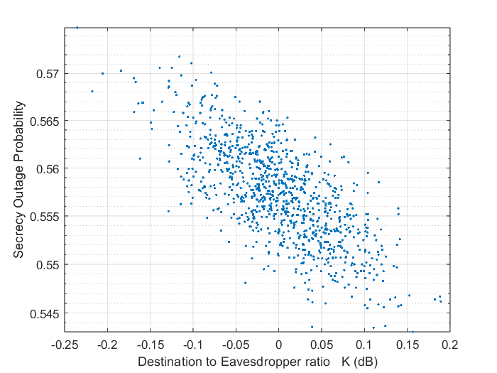

# Section 4. Weibull Fading Channel

Weibull fading is a type of radio frequency signal fading that is commonly used to model the effects of signal attenuation in wireless communication systems. The Weibull distribution is a probability distribution that is widely used in reliability and survival analysis to model the failure of mechanical and electrical systems. In the context of wireless communication, the Weibull distribution is used to model the attenuation of radio waves as they travel through a medium. Like Rayleigh fading, Weibull fading is a statistical model that is used to represent the randomness and unpredictability of signal attenuation in a wireless channel.

The main difference between Weibull fading and Rayleigh fading is the shape of the probability distribution that is used to model the signal attenuation. The Weibull distribution has a more general shape than the Rayleigh distribution, which makes it a more flexible model for a wider range of wireless environments. In particular, the Weibull distribution can be used to model wireless channels with non-uniform attenuation, while the Rayleigh distribution is best suited to modeling channels with uniform attenuation.

The non-uniform nature of the Weibull fading describes a propagation environment where the obstacles are not uniformly distributed. The amplitude of the signal is modeled by a Weibull distribution, which is characterized by two parameters: a shape parameter, k, that determines the severity of the fading, and a scale parameter, λ, that determines the location of the distribution. Weibull fading is commonly observed in environments with non-uniform terrain, such as mountainous or hilly areas.

## 4.1. System model of Weibull fading channel

Based on the Generalized Gamma Distribution of the SNR and [Reference], the Weibull SNR distribution PDF is:

The corresponding CDF is:

The Rayleigh fading PDF can be derived from the previous PDF by substituting . The expression becomes:

Knowing that , we have that:

Which is the Rayleigh PDF. Thus, the Weibull fading model is a generalization of the Rayleigh fading model.

## 4.2. Secrecy outage probability analysis

To calculate the secrecy outage probability of the Weibull fading channel, we have to solve the following expression, previously derived in Section 3.

Where the constant . Substituting the expressions inside the integral, we have the following definite integral.

The constants appearing inside the integral for simplicity reasons are:

To simplify the complex expression, a series of algebraic transformations must be done.

Having two integrals, each is solved separately.

The second integral is too difficult to solve analytically. We can firstly check, if for shape parameter, equal to 2, the integral will yield the Rayleigh fading channel.

Assuming that , the second integral is solved as such:

Substituting the two integrals in the initial expression we have:

Continuing, we can solve the second integral for shape parameters in the powers of 2. We are going to present the results for c = 4, 6 and 8.

The conditions for the upper integral are:

## 4.3. Simulations

### 4.3.1. Analytical expression simulations

### 4.3.2. Realistic system model simulations

# Section 5. Rician Fading Channel

# Section 6. Nakagami-μ Fading Channel

# Section 7. Generalized Gamma Fading Channels

# Section 8. Conclusion

# Bibliography

There are no sources in the current document.